S. Sairaj
dept. name: School of computing and data science
Sai University
Chennai, India
sairajsakhale1905@gmail.com
🚗 Vehicle Fleet Management System using C (Linked List)
M. Hari
dept. name: School of computing and data science
Sai University
Chennai, India
hariadiseshu7@gmail.com

ABSTRACT
The Vehicle Fleet Management System is a software application developed in C programming language to efficiently manage vehicle records in a structured and dynamic manner. The system is built using the singly linked list data structure, which allows efficient insertion, deletion, updating, and searching of vehicle information without the limitations of static memory allocation.
Each vehicle is represented as a node containing attributes such as vehicle ID, name, type, and mileage. The system uses dynamic memory allocation to allocate and deallocate memory at runtime, ensuring optimal memory utilization.
This project demonstrates how fundamental data structures can be applied to real-world applications such as fleet tracking and transport management systems. It also serves as a base model for more advanced systems involving databases and real-time vehicle monitoring.
Keywords— C Programming, Data Structures, Linked List, CRUD Operations, Dynamic Memory Allocation, Fleet Management
I. INTRODUCTION
In modern transportation and logistics systems, managing a large number of vehicles efficiently is a critical requirement. Traditional manual record-keeping systems are slow, error-prone, and inefficient when dealing with large datasets.
To overcome these limitations, computerized systems are introduced. This project implements a Vehicle Fleet Management System using C programming and a singly linked list data structure. The system provides a simple and interactive interface for managing vehicle data dynamically.
Linked lists are preferred over arrays because they allow dynamic memory allocation, making it easier to handle growing or shrinking datasets without memory wastage.
ΙΙ. ΟBJECTIVES
The main objectives of this project are:
- To design and implement a vehicle management system using C
- To apply linked list data structure in a real-world scenario
- To perform CRUD operations (Create, Read, Update, Delete)
- To use dynamic memory allocation effectively
- To develop a modular, menu-driven application
- To improve understanding of pointers and memory management in C
III.SCOPE OF PROJECT

Fleet management companies

Logistics and delivery services

Transport agencies

Vehicle rental organizations

The system can be further enhanced to support database storage, graphical interfaces, and real-time vehicle tracking systems.

IV. LITERATURE REVIEW

Data structures play a fundamental role in efficient data storage and manipulation. Among various data structures, linked lists are widely used for dynamic data handling due to their flexibility.

According to standard computer science principles:

Arrays have fixed size and are inefficient for dynamic operations

Linked lists allow efficient insertion and deletion

Real-world applications such as navigation systems and record management use linked lists or graph-based structures

Previous implementations of fleet systems show that linked list-based models provide better memory utilization and flexibility for dynamic datasets.

V. METHODOLOGY

The system is developed using a structured procedural approach:

Define a structure for vehicle details using struct

Create nodes dynamically using malloc()

Link nodes using pointers to form a singly linked list

Implement CRUD operations using separate functions

Provide a menu-driven interface for user interaction

Free allocated memory using free() during deletion

The system ensures modularity by separating each operation into individual functions.

VI. TECHNOLOGY USED
• Programming Language: C
• Data Structure: Singly Linked List
• Compiler: GCC
• Platform: Windows / Linux / macOS
• Interface: Console-based application

• Input/Output: Standard I/O functions (scanf, printf)

VII. ARCHITECTURE/SYSTEM DESIGN
7.1 Data Structure Design
Each vehicle is represented as a node in a linked list:
struct Vehicle {
int id;
char name[50];
char type[30];
float mileage;
struct Vehicle* next;
};
7.2 System Architecture
Head → [Vehicle] → [Vehicle] → [Vehicle] → NULL
Explanation:
- Each node stores vehicle data
- The pointer links nodes dynamically
- Head pointer stores the starting address
This design allows efficient insertion and deletion without shifting elements.
VIII. IMPLEMENTATION DETAILS
The system is implemented using modular functions:
- addVehicle() → Adds a new vehicle node at runtime
- displayVehicles() → Traverses and displays all records
- searchVehicle() → Searches a vehicle by ID
- updateVehicle() → Modifies existing vehicle details
- deleteVehicle() → Removes a node and frees memory
Memory Management:
- malloc() is used for dynamic allocation
- free() is used to release memory during deletion
This ensures efficient memory utilization and prevents memory leaks.
IX. RESULTS / OUTPUT
Sample output:
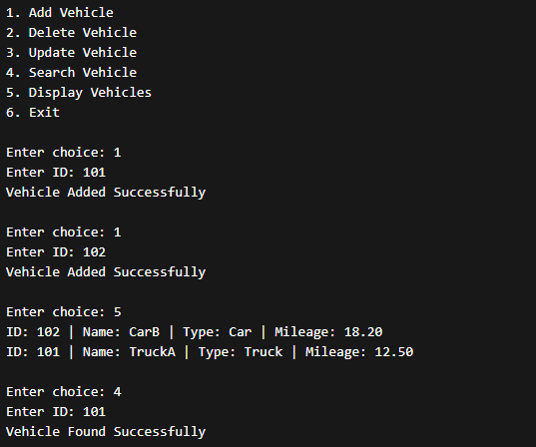
The system successfully performs all CRUD operations on vehicle data. The linked list structure allows dynamic handling of records without predefined size limitations.
Key Observations:
- Insertion is efficient as nodes are added dynamically
- Deletion does not require shifting elements
- Searching is performed using traversal
- Memory is efficiently managed using pointers
The system behaves correctly for all test cases and provides accurate output for all operations.

X. CONCLUSION
The Vehicle Fleet Management System successfully demonstrates the implementation of a singly linked list in C programming. It provides an efficient and structured approach for managing dynamic vehicle data.
The system supports all basic CRUD operations and highlights the importance of data structures in real-world applications such as transportation and logistics systems.

XI. FUTURE WORK
Future enhancements may include:
- Graphical User Interface (GUI)
- Implementing file handling for permanent storage
- Adding database integration (MySQL)
- Developing a graphical user interface (GUI)
- Adding sorting and filtering features
- Extending to real-time fleet tracking systems
- Implementing authentication for users
- Database integration
- Add station name
- Shortest path algorithms
- Web-based e-learning platform
- User authentication system
- Graphical User Interface (GUI)
- Weighted graphs (distance, cost)
- Shortest path algorithms (Dijkstra)
- Web-based transport system
- User authentication system
- Real-time data integration

XII. REFERENCES
[1] GeeksforGeeks, “Binary Search Tree Data Structure,” GeeksforGeeks, 2024. Available:https://www.geeksforgeeks.org/dsa/binary-search-tree-data-structure/
[2] [2] Programiz, “Binary Search Tree (BST),” 2023.
Available: https://www.programiz.com/dsa/binary-search-tree
[3] Baeldung, “Binary Search Trees Guide,” Baeldung, 2022. Available: https://www.baeldung.com/cs/binary-search-trees

